3. **Data Analysis and Visualization**

**Connecting Tableau with Amazon redshift**

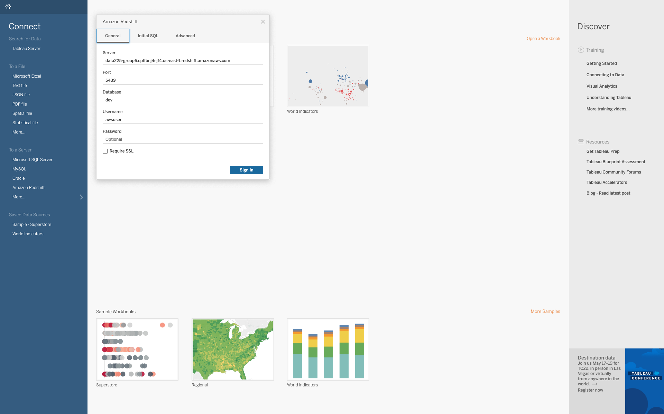

**Making relationships between the tables for multi-table Analysis**

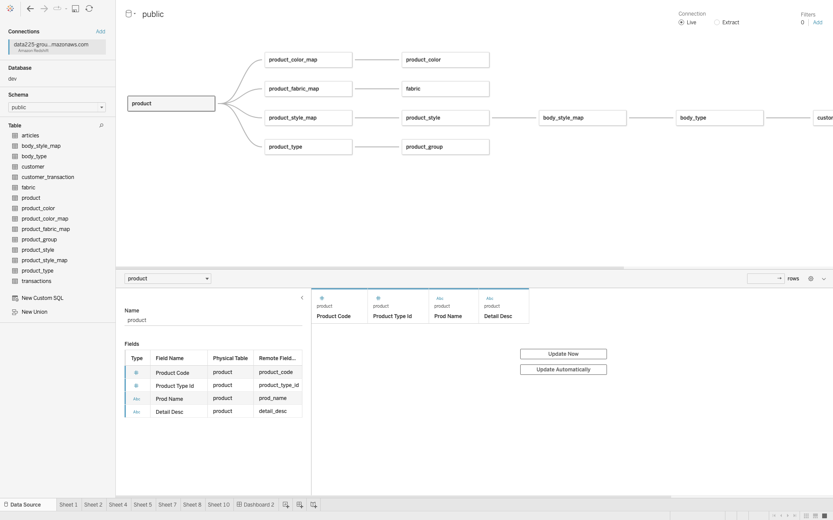

3.1 Insights according to our proposal

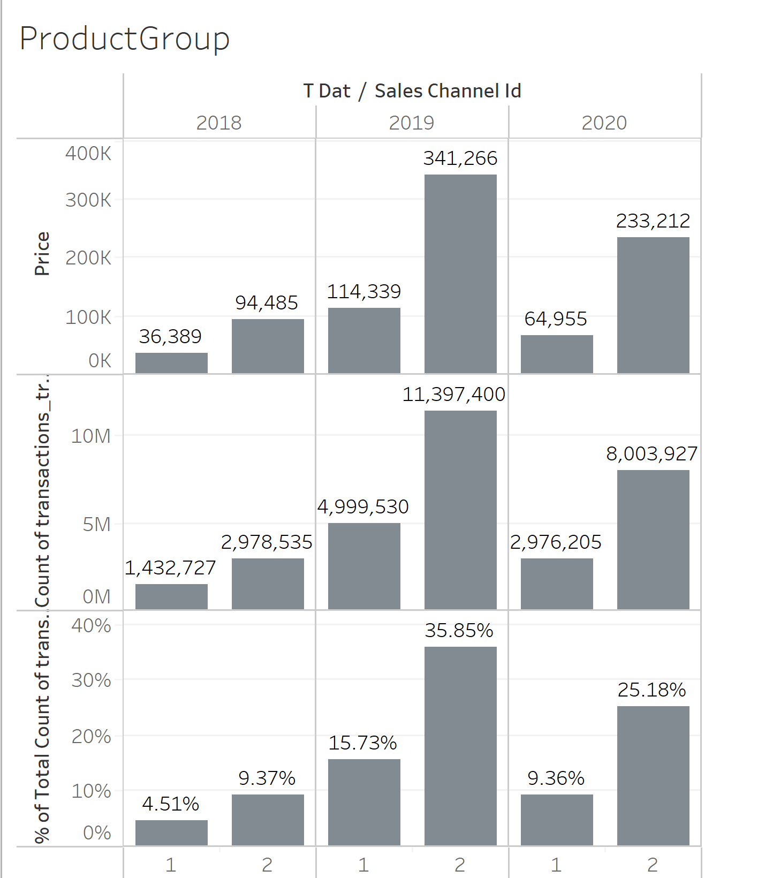

The above figure shows the distribution of transactions between two sales channels across the years, 2018-2020. We do not have full yearly data for 2018. so, we will not analyze this year. Comparing between 2019 and 2020, sales significantly dropped in both the channels. This may be due to the effect of pandemics on stores getting closed and people spending less.

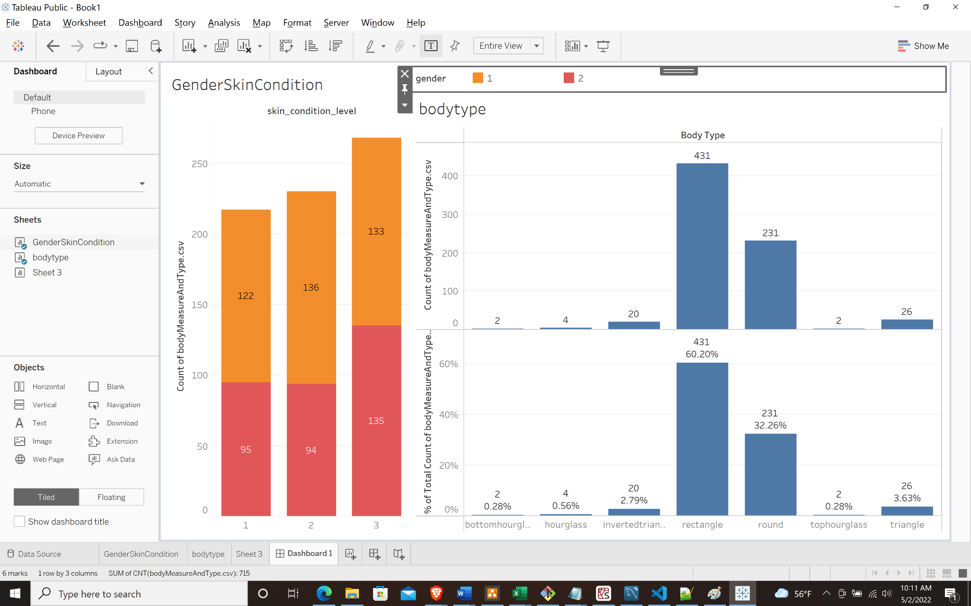

The above right graph shows the distribution of body shapes in our customer database. Most of the customers are of type rectangle followed by round, hourglass customers are the least in the count.

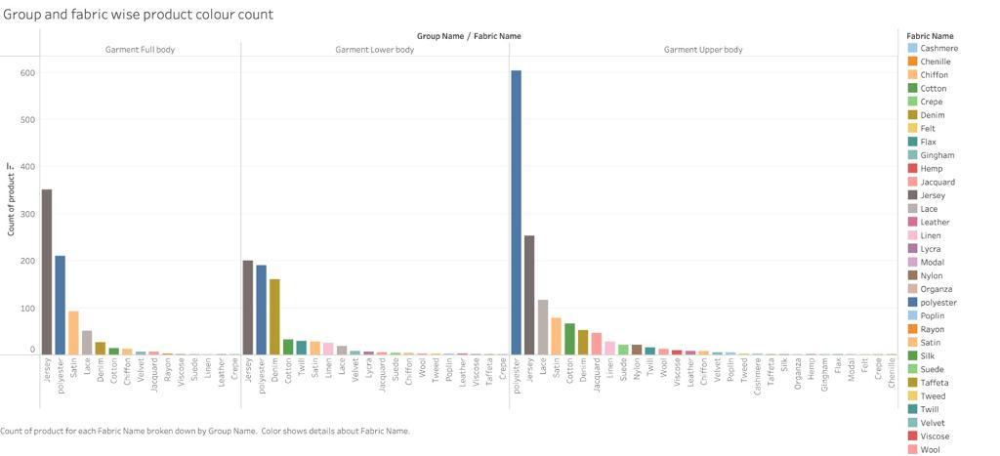

The Bar graph demonstrates which fabrics were popular with which garment categories. We can deduce from the chart that the demand for Jersey and polyester fabrics was the highest in all categories. So here, production for unpopular fabrics can be decreased. Similarly, fabric selections can be changed for all the garment types according to popularity.

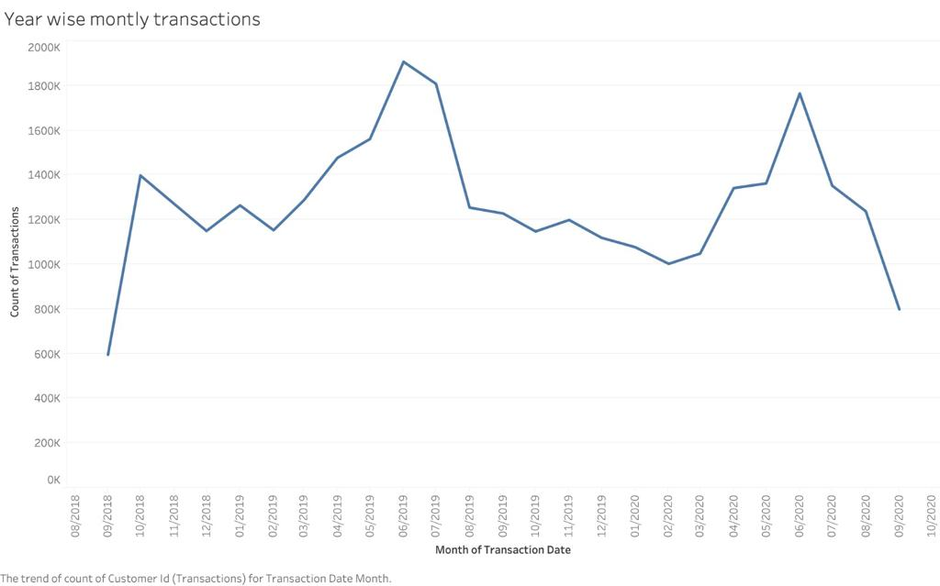

The chart represents monthly sales over the years 2018 to 2020. It is clearly evident that the sales usually have seen an upward trend from the months of Jan-Feb and peak near June. On the contrary, the sales had plummeted the most during the months of Nov to Feb. Therefore, the company can maybe improve the seasonal collection for those months.

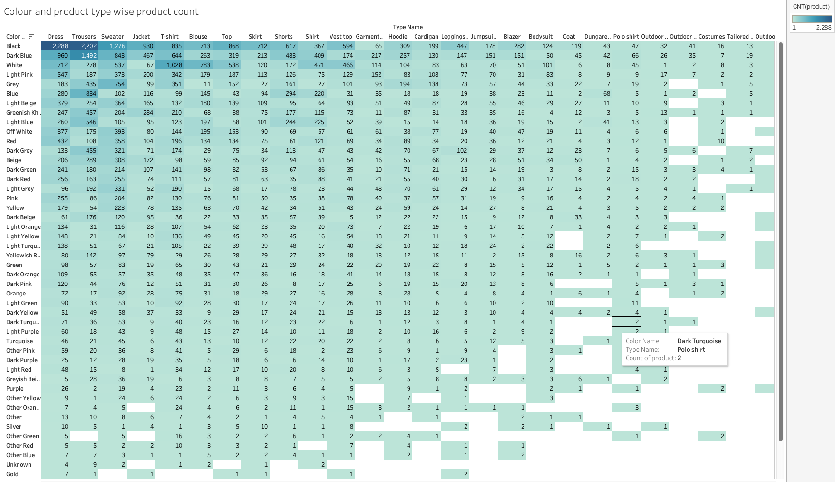

The heat map shows the sales count of the products according to the color and product type. It is evident from the figure that, Darker colors such as black, dark blue, grey, etc. are more popular in all the product types. However, white and light pink color products are still a somewhat popular choice among the customers. Therefore, the product catalog can be tweaked according to the colors popular for that particular product type.

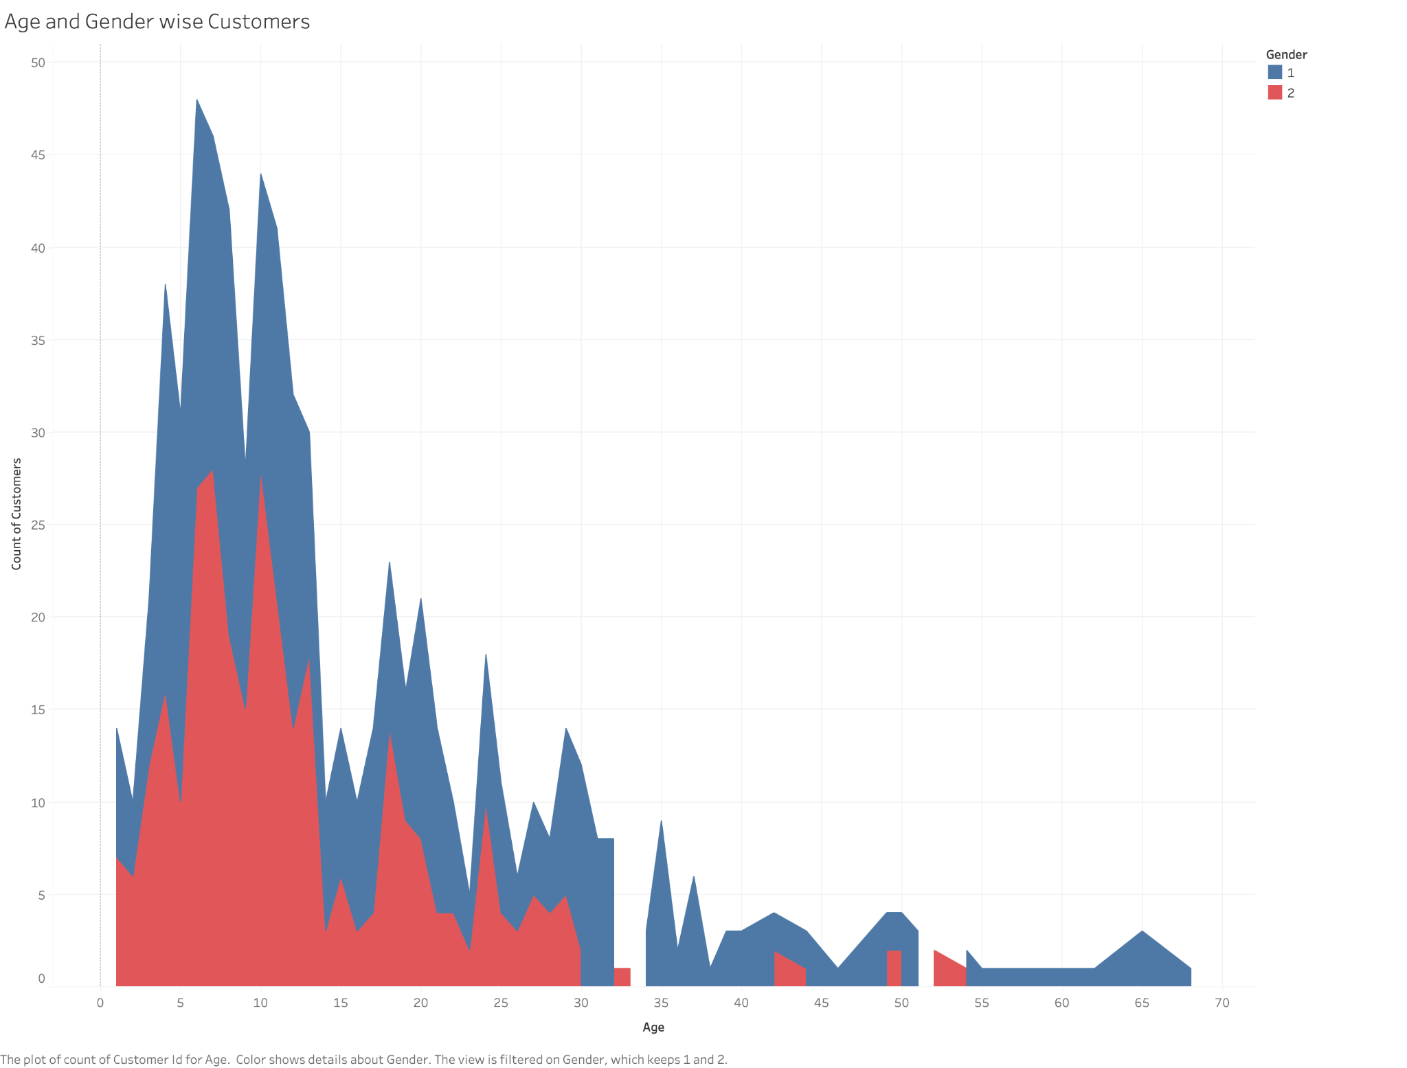

The chart shows the gender-wise customer age demographic. It's a bit unlikely that the majority of the customer fall between ages 4 to 12 but as data has been shared in a confidential manner with genders also hidden so we assume there might be some scaling in the age as well. Hence, the company could place steps in motion to attract customers from low-performing age brackets.